* [Projects](https://darey.io/project-listings/" \o "Projects" \t "_blank)
* [Docs](https://www.darey.io/projects/)
* [(STEP 37): PROJECT 23: Persisting Data in Kubernetes](https://www.darey.io/docs/persisting-data-in-kubernetes/)

**PERSISTING DATA IN KUBERNETES**

[Start Project](https://www.darey.io/docs/persisting-data-in-kubernetes/?checkread=1)Submit Project for Review

NOTE: Create EKS cluster first before the below section

Now we know that containers are stateless by design, which means that data does not persist in the containers. Even when you run the containers in kubernetes pods, they still remain stateless unless you ensure that your configuration supports statefulness.

To achieve statefuleness in kubernetes, you must understand how volumes, persistent volumes, and persistent volume claims work.

Volumes

On-disk files in a container are ephemeral, which presents some problems for non-trivial applications when running in containers. One problem is the loss of files when a container crashes. The kubelet restarts the container but with a clean state. A second problem occurs when sharing files between containers running together in a Pod. The Kubernetes volume abstraction solves both of these problems

Docker has a concept of volumes, though it is somewhat looser and less managed. A Docker volume is a directory on disk or in another container. Docker provides volume drivers, but the functionality is somewhat limited.

Kubernetes supports many types of volumes. A Pod can use any number of volume types simultaneously. Ephemeral volume types have a lifetime of a pod, but persistent volumes exist beyond the lifetime of a pod. When a pod ceases to exist, Kubernetes destroys ephemeral volumes; however, Kubernetes does not destroy persistent volumes. For any kind of volume in a given pod, data is preserved across container restarts.

At its core, a volume is a directory, possibly with some data in it, which is accessible to the containers in a pod. How that directory comes to be, the medium that backs it, and the contents of it are all determined by the particular **volume type** used. This means, you must know some of the different types of volumes available in kubernetes before choosing what is ideal for your particular use case.

Lets have a look at a few of them.

**awsElasticBlockStore**

An awsElasticBlockStore volume mounts an **Amazon Web Services (AWS) EBS** volume into your pod. The contents of an EBS volume are persisted and the volume is only unmmounted when the pod crashes, or terminates. This means that an EBS volume can be pre-populated with data, and that data can be shared between pods.

Lets see what it looks like for our Nginx pod to persist data using awsElasticBlockStore volume

sudo cat <<EOF | sudo tee ./nginx-pod.yaml

apiVersion: apps/v1

kind: Deployment

metadata:

name: nginx-deployment

labels:

tier: frontend

spec:

replicas: 1

selector:

matchLabels:

tier: frontend

template:

metadata:

labels:

tier: frontend

spec:

containers:

- name: nginx

image: nginx:latest

ports:

- containerPort: 80

volumes:

- name: nginx-volume

# This AWS EBS volume must already exist.

awsElasticBlockStore:

volumeID: "<volume id>"

fsType: ext4

EOF

The **volume** section indicates the type of volume to be used to ensure persistence.

If you notice the config above carefully, you will realise that there is need to provide a ***volumeID*** before the deployment will work. Therefore, You must create an **EBS** volume by using aws ec2 create-volume command or the AWS console.

Before you create a volume, lets run the nginx deployment into kubernetes without a volume.

sudo cat <<EOF | sudo tee ./nginx-pod.yaml

apiVersion: apps/v1

kind: Deployment

metadata:

name: nginx-deployment

labels:

tier: frontend

spec:

replicas: 3

selector:

matchLabels:

tier: frontend

template:

metadata:

labels:

tier: frontend

spec:

containers:

- name: nginx

image: nginx:latest

ports:

- containerPort: 80

EOF

**Tasks**

* Verify that the pod is running
* Check the logs of the pod
* Exec into the pod and navigate to the nginx configuration file /etc/nginx/conf.d
* Open the config files to see the default configuration.

**NOTE:** There are some restrictions when using an awsElasticBlockStore volume:

* The nodes on which pods are running must be AWS EC2 instances
* Those instances need to be in the same region and availability zone as the EBS volume
* EBS only supports a single EC2 instance mounting a volume

Now that we have the pod running without a volume, Lets now create a volume from the AWS console.

1. In your AWS console, head over to the EC2 section and scroll down to the **Elastic Block Storage** menu.
2. Click on Volumes
3. At the top right, click on **Create Volume** 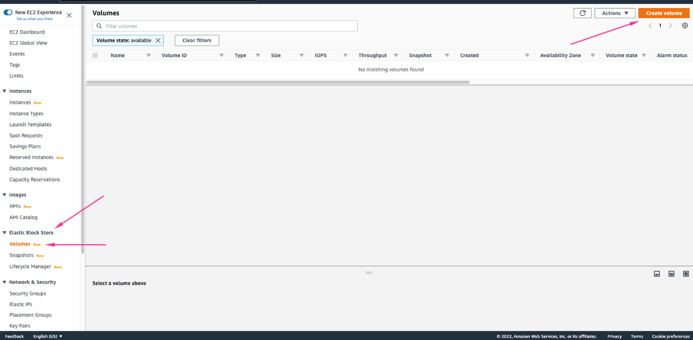

Part of the requirements is to ensure that the volume exists in the same region and availability zone as the EC2 instance running the pod. Hence, we need to find out

* Which node is running the pod (replace the pod name with yours)

kubectl get po nginx-deployment-6fdcffd8fc-thcfp -o wide

Output:

NAME READY STATUS RESTARTS AGE IP NODE NOMINATED NODE READINESS GATES

nginx-deployment-6fdcffd8fc-thcfp 1/1 Running 0 64m 10.0.3.159 ip-10-0-3-233.eu-west-2.compute.internal <none> <none>

The NODE column shows the node the pode is running on

* In which Availability Zone the node is running.

kubectl describe node ip-10-0-3-233.eu-west-2.compute.internal

The information is written in the labels section of the descibe command.  
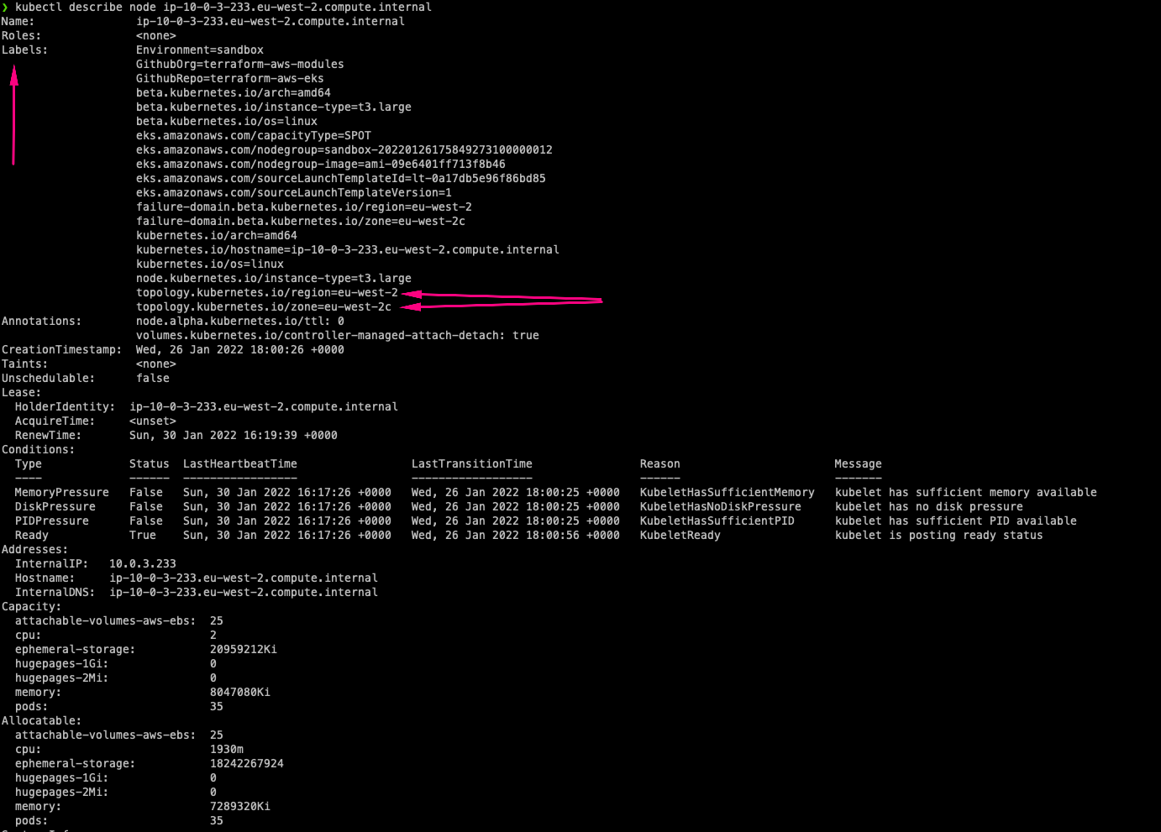

1. So, in the case above, we know the AZ for the node is in eu-west-2c hence, the volume must be created in the same AZ. Choose the size of the required volume.

The **create volume** selection should be like:

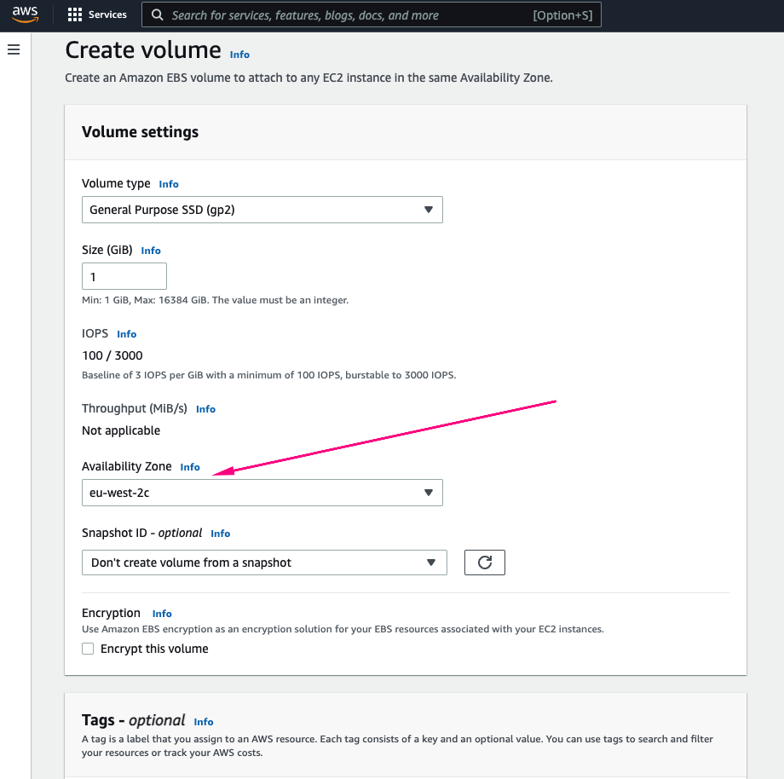

1. Copy the VolumeID

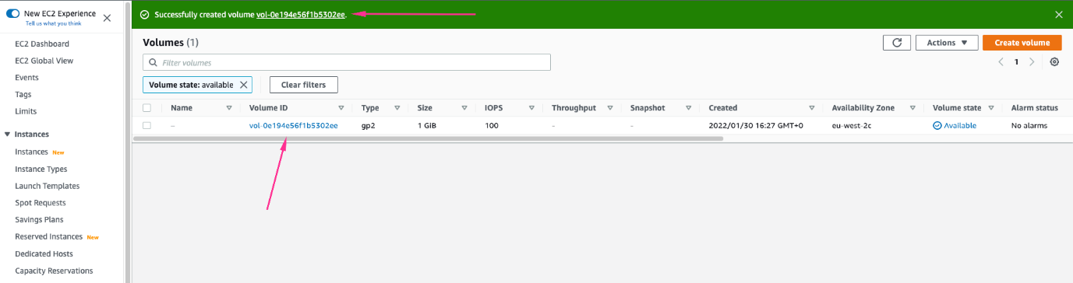

1. Update the deployment configuration with the volume spec.

sudo cat <<EOF | sudo tee ./nginx-pod.yaml

apiVersion: apps/v1

kind: Deployment

metadata:

name: nginx-deployment

labels:

tier: frontend

spec:

replicas: 1

selector:

matchLabels:

tier: frontend

template:

metadata:

labels:

tier: frontend

spec:

containers:

- name: nginx

image: nginx:latest

ports:

- containerPort: 80

volumes:

- name: nginx-volume

# This AWS EBS volume must already exist.

awsElasticBlockStore:

volumeID: "vol-0e194e56f1b5302ee"

fsType: ext4

EOF

Apply the new configuration and check the pod. As you can see, the old pod is being terminated while the updated one is up and running.

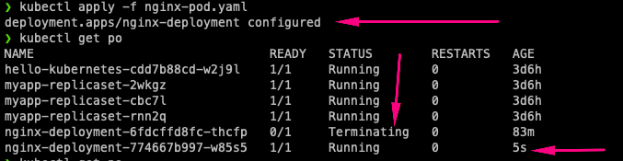

Now, the new pod has a volume attached to it, and can be used to run a container for statefuleness. Go ahead and explore the running pod. Run describe on both the **pod** and **deployment**

At this point, even though the pod can be used for a stateful application, the configuration is not yet complete. This is because, the volume is not yet mounted onto any specific filesystem inside the container. The directory /usr/share/nginx/html which holds the software/website code is still ephemeral, and if there is any kind of update to the index.html file, the new changes will only be there for as long as the pod is still running. If the pod dies after, all previously written data will be erased.

To complete the configuration, we will need to add another section to the deployment yaml manifest. The **volumeMounts** which basically answers the question "Where should this *Volume* be mounted inside the container?" Mounting a volume to a directory means that all data written to the directory will be stored on that volume.

Lets do that now.

cat <<EOF | tee ./nginx-pod.yaml

apiVersion: apps/v1

kind: Deployment

metadata:

name: nginx-deployment

labels:

tier: frontend

spec:

replicas: 1

selector:

matchLabels:

tier: frontend

template:

metadata:

labels:

tier: frontend

spec:

containers:

- name: nginx

image: nginx:latest

ports:

- containerPort: 80

volumeMounts:

- name: nginx-volume

mountPath: /usr/share/nginx/

volumes:

- name: nginx-volume

# This AWS EBS volume must already exist.

awsElasticBlockStore:

volumeID: " vol-07b537651bbe68be0"

fsType: ext4

EOF

Notice the newly added section:

volumeMounts:

- name: nginx-volume

mountPath: /usr/share/nginx/

* The value provided to name in volumeMounts must be the same value used in the volumes section. It basically means mount the volume with the name provided, to the provided mountpath

In as much as we now have a way to persist data, we also have new problems.

1. If you port forward the service and try to reach the endpoint, you will get a 403 error. This is because mounting a volume on a filesystem that already contains data will automatically erase all the existing data. This strategy for statefulness is preferred if the mounted volume already contains the data which you want to be made available to the container  
   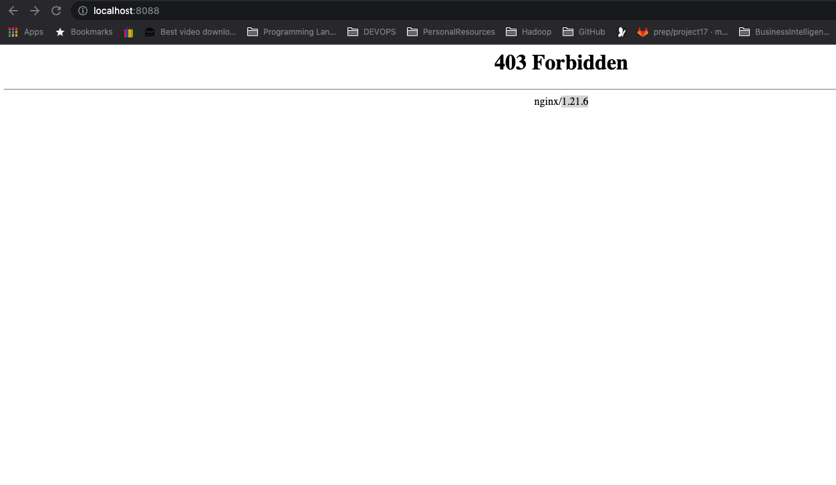
2. It is still a manual process to create a volume, manually ensure that the volume created is in the same Avaioability zone in which the pod is running, and then update the manifest file to use the volume ID. All of these is against DevOps principles because it will mean having a lot of road blocks to getting a simple thing done.

The more elegant way to achieve this is through Persistent Volume and Persistent Volume claims.

In kubernetes, there are many elegant ways of persisting data. Each of which is used to satisfy different use cases. Lets take a look at the different options available.

1. **Persistent Volume (PV)** and **Persistent Volume Claim (PVC)**
2. **configMap**

**MANAGING VOLUMES DYNAMICALLY WITH PVS AND PVCS**

Kubernetes provides API objects for storage management such that, the lower level details of volume provisioning, storage allocation, access management etc are all abstracted away from the user, and all you have to do is present manifest files that describes what you want to get done.

**PVs** are volume plugins that have a lifecycle completely independent of any individual Pod that uses the PV. This means that even when a pod dies, the PV remains. A **PV** is a piece of storage in the cluster that is either provisioned by an administrator through a manifest file, or it can be dynamically created if a storage class has been pre-configured.

Creating a PV manually is like what we have done previously where with creating the volume from the console. As much as possible, we should allow PVs to be created automatically just be adding it to the container spec iin deployments. But without a storageclass present in the cluster, PVs cannot be automatically created.

If your infrastructure relies on a storage system such as NFS, iSCSI or a cloud provider-specific storage system such as EBS on AWS, then you can dynamically create a PV which will create a volume that a Pod can then use. This means that there must be a **storageClass** resource in the cluster before a PV can be provisioned.

By default, in EKS, there is a default **storageClass** configured as part of EKS installation. This storageclass is based on **gp2** which is Amazon’s default type of volume for Elastic block storage.**gp2** is backled by solid-state drives (SSDs) which means they are suitable for a broad range of transactional workloads.

Run the command below to check if you already have a storageclass in your cluster kubectl get storageclass

kubectl get storageclass

NAME PROVISIONER RECLAIMPOLICY VOLUMEBINDINGMODE ALLOWVOLUMEEXPANSION AGE

gp2 (default) kubernetes.io/aws-ebs Delete WaitForFirstConsumer false 18d

Of course, if the cluster is not EKS, then the storage class will be different. For example if the cluster is based on Google’s **GKE** or Azure’s **AKS**, then the storage class will be different.

If there is no storage class in your cluster, below manifest is an example of how one would be created

kind: StorageClass

apiVersion: storage.k8s.io/v1

metadata:

name: gp2

annotations:

storageclass.kubernetes.io/is-default-class: "true"

provisioner: kubernetes.io/aws-ebs

parameters:

type: gp2

fsType: ext4

A PersistentVolumeClaim (PVC) on the other hand is a request for storage. Just as Pods consume node resources, PVCs consume PV resources. Pods can request specific levels of resources (CPU and Memory). Claims can request specific size and access modes (e.g., they can be mounted ReadWriteOnce, ReadOnlyMany or ReadWriteMany, see [AccessModes](https://kubernetes.io/docs/concepts/storage/persistent-volumes/#access-modes)).

**Lifecycle of a PV and PVC**

PVs are resources in the cluster. PVCs are requests for those resources and also act as claim checks to the resource. The interaction between PVs and PVCs follows this lifecycle:

1. **Provisioning**: There are two ways PVs may be provisioned: statically or dynamically.
   * Static/Manual Provisioning: A cluster administrator creates a number of PVs using a manifest file which will contain all the details of the real storage. PVs are not scoped to namespaces, they a clusterwide wide resource, therefore the PV will be available for use when requested. PVCs on the other hand are namespace scoped.
   * Dynamic: When there is no PV matching a PVC’s request, then based on the available StorageClass, a dynamic PV will be created for use by the PVC. If there is not StorageClass, then the request for a PV by the PVC will fail.
2. **Binding**: PVCs are bound to specifiv PVs. This binding is exclusive. A PVC to PV binding is a one-to-one mapping. Claims will remain unbound indefinitely if a matching volume does not exist. Claims will be bound as matching volumes become available. For example, a cluster provisioned with many 50Gi PVs would not match a PVC requesting 100Gi. The PVC can be bound when a 100Gi PV is added to the cluster.
3. **Using**: Pods use claims as volumes. The cluster inspects the claim to find the bound volume and mounts that volume for a Pod. For volumes that support multiple access modes, the user specifies which mode is desired when using their claim as a volume in a Pod. Once a user has a claim and that claim is bound, the bound PV belongs to the user for as long as they need it. Users schedule Pods and access their claimed PVs by including a persistentVolumeClaim section in a Pod’s volumes block
4. **Storage Object in Use Protection**: The purpose of the Storage Object in Use Protection feature is to ensure that PersistentVolumeClaims (PVCs) in active use by a Pod and PersistentVolume (PVs) that are bound to PVCs are not removed from the system, as this may result in data loss. **Note**: PVC is in active use by a Pod when a Pod object exists that is using the PVC. If a user deletes a PVC in active use by a Pod, the PVC is not removed immediately. PVC removal is postponed until the PVC is no longer actively used by any Pods. Also, if an admin deletes a PV that is bound to a PVC, the PV is not removed immediately. PV removal is postponed until the PV is no longer bound to a PVC.
5. **Reclaiming**: When a user is done with their volume, they can delete the PVC objects from the API that allows reclamation of the resource. The reclaim policy for a PersistentVolume tells the cluster what to do with the volume after it has been released of its claim. Currently, volumes can either be Retained, Recycled, or Deleted.
   * Retain: The Retain reclaim policy allows for manual reclamation of the resource. When the PersistentVolumeClaim is deleted, the PersistentVolume still exists and the volume is considered "released". But it is not yet available for another claim because the previous claimant’s data remains on the volume.
   * Delete: For volume plugins that support the Delete reclaim policy, deletion removes both the PersistentVolume object from Kubernetes, as well as the associated storage asset in the external infrastructure, such as an AWS EBS. Volumes that were dynamically provisioned inherit the reclaim policy of their StorageClass, which defaults to **Delete**

**NOTES**:

1. When PVCs are created with a specific size, it cannot be expanded except the storageClass is configured to allow expansion with the allowVolumeExpansion field is set to **true** in the manifest YAML file. This is "unset" by default in EKS.
2. When a PV has been provisioned in a specific availability zone, only pods running in that zone can use the PV. If a pod spec containing a PVC is created in another AZ and attempts to reuse an already bound PV, then the pod will remain in pending state and report volume node affinity conflict. Anytime you see this message, this will help you to understand what the problem is.
3. PVs are not scoped to namespaces, they a clusterwide wide resource. PVCs on the other hand are namespace scoped.

Learn more about the different types of [persistent volumes here](https://kubernetes.io/docs/concepts/storage/persistent-volumes/#types-of-persistent-volumes)

Now lets create some persistence for our nginx deployment. We will use 2 different approaches.

Approach 1

1. Create a manifest file for a PVC, and based on the **gp2** storageClass a PV will be dynamically created

apiVersion: v1

kind: PersistentVolumeClaim

metadata:

name: nginx-volume-claim

spec:

accessModes:

- ReadWriteOnce

resources:

requests:

storage: 2Gi

storageClassName: gp2

```

Apply the manifest file and you will get an output like below

persistentvolumeclaim/nginx-volume-claim created

Run get on the pvc and you will notice that it is in pending state.

kubectl get pvc  
NAME STATUS VOLUME CAPACITY ACCESS MODES STORAGECLASS AGE  
nginx-volume-claim Pending gp2 61s

To troubleshoot this, simply run a describe on the pvc. Then you will see in the Message section that this pvc is waiting for the first consumer to be created before binding the PV to a PV

Name: nginx-volume-claim  
Namespace: default  
StorageClass: gp2  
Status: Pending  
Volume:  
Labels:  
Annotations:  
Finalizers: [kubernetes.io/pvc-protection]  
Capacity:  
Access Modes:  
VolumeMode: Filesystem  
Used By:  
Events:  
Type Reason Age From Message

Normal WaitForFirstConsumer 7s (x11 over 2m24s) persistentvolume-controller waiting for first consumer to be created before binding

If you run `kubectl get pv` you will see that no PV is created yet. The \*waiting for first consumer to be created before binding\* is a configuration setting from the storageClass. See the `VolumeBindingMode` section below.

kubectl describe storageclass gp2  
Name: gp2  
IsDefaultClass: Yes  
Annotations: kubectl.kubernetes.io/last-applied-configuration={"apiVersion":"storage.k8s.io/v1","kind":"StorageClass","metadata":{"annotations":{"storageclass.kubernetes.io/is-default-class":"true"},"name":"gp2"},"parameters":{"fsType":"ext4","type":"gp2"},"provisioner":"kubernetes.io/aws-ebs","volumeBindingMode":"WaitForFirstConsumer"}  
,storageclass.kubernetes.io/is-default-class=true  
Provisioner: kubernetes.io/aws-ebs  
Parameters: fsType=ext4,type=gp2  
AllowVolumeExpansion:  
MountOptions:  
ReclaimPolicy: Delete  
VolumeBindingMode: WaitForFirstConsumer  
Events:

To proceed, simply apply the new deployment configuration below.

2. Then configure the Pod spec to use the PVC

apiVersion: apps/v1

kind: Deployment

metadata:

name: nginx-deployment

labels:

tier: frontend

spec:

replicas: 1

selector:

matchLabels:

tier: frontend

template:

metadata:

labels:

tier: frontend

spec:

containers:

- name: nginx

image: nginx:latest

ports:

- containerPort: 80

volumeMounts:

- name: nginx-volume-claim

mountPath: "/tmp/dare"

volumes:

- name: nginx-volume-claim

persistentVolumeClaim:

claimName: nginx-volume-claim

Notice that the volumes section nnow has a `persistentVolumeClaim`. With the new deployment manifest, the `/tmp/dare` directory will be persisted, and any data written in there will be sotred permanetly on the volume, which can be used by another Pod if the current one gets replaced.

Now lets check the dynamically created PV

kubectl get pv  
NAME CAPACITY ACCESS MODES RECLAIM POLICY STATUS CLAIM STORAGECLASS REASON AGE  
pvc-89ba00d9-68f4-4039-b19e-a6471aad6a1e 2Gi RWO Delete Bound default/nginx-volume-claim gp2 7s

You can copy the PV Name and search in the AWS console. You will notice that the volum has been dynamically created there.

![](https://www.darey.io/wp-content/uploads/2022/04/PV-volume.png)

Approach 2 (Attempt this on your own). [See an example here](https://www.elastic.co/guide/en/cloud-on-k8s/current/k8s-volume-claim-templates.html)

1. Create a volumeClaimTemplate within the Pod spec. This approach is simply adding the manifest for PVC right within the Pod spec of the deployment.

2. Then use the PVC name just as Approach 1 above.

So rather than have 2 manifest files, you will define everything within the deployment manifest.

**CONFIGMAP**

Using configMaps for persistence is not something you would consider for data storage. Rather it is a way to manage configuration files and ensure they are not lost as a result of Pod replacement.

to demonstrate this, we will use the HTML file that came with Nginx. This file can be found in /usr/share/nginx/html/index.html  directory.

Lets go through the below process so that you can see an example of a configMap use case.

1. Remove the **volumeMounts** and **PVC** sections of the manifest and use kubectl to apply the configuration
2. port forward the service and ensure that you are able to see the **"Welcome to nginx"** page
3. exec into the running container and keep a copy of the **index.html** file somewhere. For example

kubectl exec -it nginx-deployment-79d8c764bc-j6sp9 -- bash

cat /usr/share/nginx/html/index.html

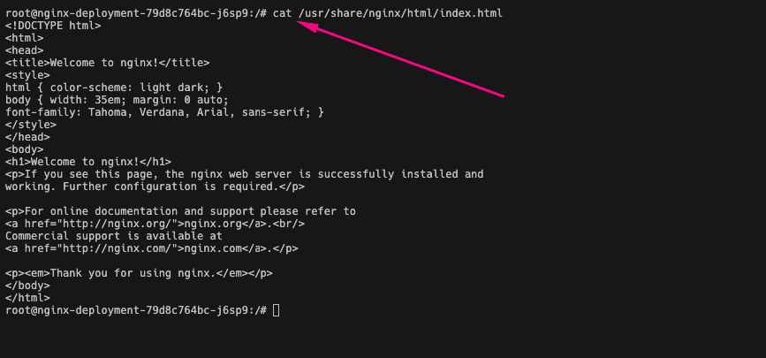

1. Copy the output and save the file on your local pc because we will need it to create a configmap.

**Persisting configuration data with configMaps**

According to the official documentation of [**configMaps**](https://kubernetes.io/docs/concepts/configuration/configmap/), A ConfigMap is an API object used to store non-confidential data in key-value pairs. Pods can consume ConfigMaps as environment variables, command-line arguments, or as configuration files in a volume.

In our own use case here, We will use configMap to create a file in a volume.

The manifest file we look like:

cat <<EOF | tee ./nginx-configmap.yaml

apiVersion: v1

kind: ConfigMap

metadata:

name: website-index-file

data:

# file to be mounted inside a volume

index-file: |

<!DOCTYPE html>

<html>

<head>

<title>Welcome to nginx!</title>

<style>

html { color-scheme: light dark; }

body { width: 35em; margin: 0 auto;

font-family: Tahoma, Verdana, Arial, sans-serif; }

</style>

</head>

<body>

<h1>Welcome to nginx!</h1>

<p>If you see this page, the nginx web server is successfully installed and

working. Further configuration is required.</p>

<p>For online documentation and support please refer to

<a href="http://nginx.org/">nginx.org</a>.<br/>

Commercial support is available at

<a href="http://nginx.com/">nginx.com</a>.</p>

<p><em>Thank you for using nginx.</em></p>

</body>

</html>

EOF

* Apply the new manifest file

kubectl apply -f nginx-configmap.yaml

* Update the deployment file to use the configmap in the volumeMounts section

cat <<EOF | tee ./nginx-pod-with-cm.yaml

apiVersion: apps/v1

kind: Deployment

metadata:

name: nginx-deployment

labels:

tier: frontend

spec:

replicas: 1

selector:

matchLabels:

tier: frontend

template:

metadata:

labels:

tier: frontend

spec:

containers:

- name: nginx

image: nginx:latest

ports:

- containerPort: 80

volumeMounts:

- name: config

mountPath: /usr/share/nginx/html

readOnly: true

volumes:

- name: config

configMap:

name: website-index-file

items:

- key: index-file

path: index.html

EOF

* Now the index.html file is no longer ephemeral because it is using a configMap that has been mounted onto the filesystem. This is now evident when you exec into the pod and list the /usr/share/nginx/html directory

root@nginx-deployment-84b799b888-fqzwk:/# ls -ltr /usr/share/nginx/html

lrwxrwxrwx 1 root root 17 Feb 19 16:16 index.html -> ..data/index.html

You can now see that the index.html is now a soft link to ../data

* Accessing the site will not change anything at this time because the same html file is being loaded through configmap.
* But if you make any change to the content of the html file through the configmap, and restart the pod, all your changes will persist.

Lets try that;

* List the available configmaps. You can either use kubectl get configmap or kubectl get cm
* kubectl get cm
* NAME DATA AGE
* kube-root-ca.crt 1 17d

website-index-file 1 46m

We are interested in the **website-index-file** configmap

* Update the configmap. You can either update the manifest file, or the kubernetes object directly. Lets use the latter approach this time.

kubectl edit cm website-index-file

It will open up a vim editor, or whatever default editor your system is configured to use. Update the content as you like. "Only the html data section", then save the file.

You should see an output like this

configmap/website-index-file edited

apiVersion: v1

kind: ConfigMap

metadata:

name: website-index-file

data:

# file to be mounted inside a volume

index-file: |

<!DOCTYPE html>

<html>

<head>

<title>Welcome to DAREY.IO!</title>

<style>

html { color-scheme: light dark; }

body { width: 35em; margin: 0 auto;

font-family: Tahoma, Verdana, Arial, sans-serif; }

</style>

</head>

<body>

<h1>Welcome to DAREY.IO!</h1>

<p>If you see this page, It means you have successfully updated the configMap data in Kubernetes.</p>

<p>For online documentation and support please refer to

<a href="http://DAREY.IO/">DAREY.IO</a>.<br/>

Commercial support is available at

<a href="http://DAREY.IO/">DAREY.IO</a>.</p>

<p><em>Thank you and make sure you are on Darey's Masterclass Program.</em></p>

</body>

</html>

Without restarting the pod, your site should be loaded automatically.



If you wish to restart the deployment for any reason, simply use the command

kubectl rollout restart deploy nginx-deployment

output:

deployment.apps/nginx-deployment restarted

This will terminate the running pod and spin up a new one.

Congratulations!!!

In the next project

* You will also be introduced to packaging Kubernetes manifests using [**Helm**](https://helm.sh/)
* Deploying applications into Kubernetes using Helm Charts
* And many more awesome technologies